The challenges of using artificial intelligence in Business Process Improvement

L1 : SOK SABAYE

Nowadays, speed, quality, and cost efficiency are businesses main priorities. To achieve these, companies used **Process Mining (PM)**, which extracts insights from **event logs** to optimize real processes. By utilizing **Recurrent Neural Networks (RNNs)** and **Long Short-Term Memory (LSTM)**, businesses can analyze data sequentially, learning from past events to predict future outcomes. **Bidirectional LSTM (BLSTM)** enhances this by capturing information from both past and future contexts. The process culminates in graph-based analysis, leveraging event logs and **Petri nets** to address conflicts and improve system performance.

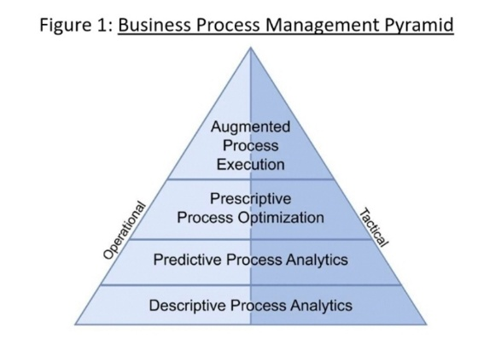AI has diverse applications, from regulating oven temperatures in the food sector to categorize URL based on the clickrate. In healthcare, **Process Mining in Organization (PMO)** utilizes **Business Process Modeling (BPM)** to visualize systems in a four-layer pyramid.

**Responsible Data Science (RDS)** emphasizes ethical data use to ensure fairness, transparency, and privacy amidst AI advancements.

AI enhances PM but faces limitations in predicting novel scenarios, leading to the development of a three-step heuristic algorithm for business processes adjustment. The Apriori system, an algorithm in data mining, extracts association rules from transactional databases based on support and confidence principles, measuring model quality, process efficiency, and impact. **General Systems Theory (GST)** identifies common principles across diverse systems, promoting holistic understanding. Process Mining application in education (Learn Health System) aids student planning and curriculum design. But it is also important to use the correct Machine Learning depending of the tasks asked.